RESOLUTION NO.__________

RE: CERTIFICATE OF APPROPRIATENESS UNDER THE
PROVISIONS OF THE ACT OF THE PENNSYLVANIA
LEGISLATURE 1961, JUNE 13, P.L. 282 (53
SECTION 8004) AND BETHLEHEM ORDINANCE NO.
3952 AS AMENDED.

WHEREAS, it is proposed to install vinyl window signs and graphics at 305 W 4th St.

NOW, THEREFORE, BE IT RESOLVED by the Council of the City of Bethlehem that a Certificate of Appropriateness is hereby granted for the work.

Sponsored by: (s)

(s)

ADOPTED BY COUNCIL THIS DAY OF

(s)
President of Council

ATTEST:

(s)
City Clerk

HISTORIC CONSERVATION COMMISSION

CASE # 432 – It is proposed to install vinyl window signs and graphics at 305 W 4th St.
OWNER/APPLICANT: Bethlehem Drug Store LLC / Kimmie Schafer

The Commission upon motion by Mr. Lader and seconded by Mr. Evans adopted the proposal that City Council issue a Certificate of Appropriateness for the proposed work described herein:

- The proposal to install vinyl window signs and graphics at 305 W 4th St. was presented by J. Michael Hussle.

- The new window signs and graphics will be modified to include an overlay of images of historic South Bethlehem buildings. Shop drawings of the proposed images are to be submitted to the HCC for review at one of its next regularly scheduled meetings.

- Although the first option is strongly preferred and recommended by the HCC, the second acceptable option is to install a more muted design of the submitted graphics described below. The color of the graphics should blend with the existing brick color, and a new color rendering must be submitted for review by the Historic Officer.

- The window graphics will be 61 3/8” wide by approximately 28” high in window numbers 1-11.

- Vinyl signs measuring 61 3/8” wide x 12” will be installed above the graphics in window numbers 1-4 reading “health, beauty, photo, pharmacy” respectively.

- Windows 8-11 will have additional vinyl graphics measuring 29 3/8” x approximately 26” installed above the larger graphic panels.

- The proposed motion was unanimously approved.

CU: cu

By: 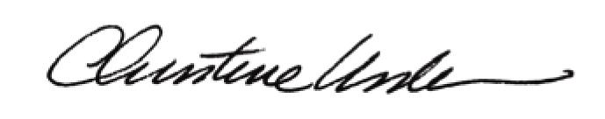

Date of Meeting: October 15, 2012 Title: Historic Officer

